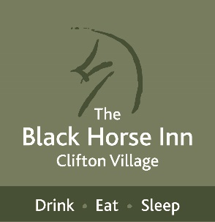

**Starters**

**Winter Vegetable Soup(v),** Homemade Bread **£8.00**

**King Prawns & Chorizo,** Cider Sauce, Homemade Bread **£12.00**

**Garlic Mushrooms (v),** Yorkshire Blue Cheese **£9.00**

**Goats Cheese Brûlée (v),** Textures of Beetroot, Rocket Salad **£10.00**

**Pork Scotch Egg,** House Chutney, Dressed Leaves **£10.00**

**Mains**

**Roast Topside of Beef, Chicken Breast, Or Honey Glazed Gammon,** served with

Roast and Mashed Potatoes, Honey Roast Carrot, Greens, Red Cabbage,

Cauliflower Cheese, Yorkshire Pudding & Gravy **£19.00**

**Steak & Ale Pie in Shortcrust Pastry,** Hand Cut Chips, Buttered Greens, Gravy

(30 mins cooking time) **£19.50**

**Black Horse Nut Roast (ve),** Red Pepper Jam, Roast Potatoes, Parsnip Puree,

Beetroot Crisps **£18.00**

**Pan fried Coley,** Shallot Puree, Crushed New Potatoes, Pickled Samphire,

Lemon & Caper Butter **£24.00**

**Roast Chicken Supreme,** Garlic & Parmesan Crumb, Creamy Mash, Greens,

Garlic Butter **£23.00**

**Buttermilk Chicken Burger,** Homemade Bun, Burger Sauce, Gherkin, Gouda,

Skinny Fries, Onion Ring, Coleslaw **£19.00**

**Haddock in Gluten Free Batter,** Hand Cut Chips **£18.75** Small Haddock **£14.50**

***Minted Mushy Peas or Tartare Sauce*** ***£*1.25**

**Sides £4.50**

**Hand Cooked Chips / Skinny Fries / Buttered Greens / Onion Rings in GF Batter**

**Goose Fat Roasties / Chilli & Sesame Broccoli / Cauliflower Cheese**

**Desserts £8.50**

**Chocolate Brownie,** White Chocolate Sauce, Vanilla Ice Cream

**Sticky Toffee Pudding,** Butterscotch Sauce, Honeycomb Ice Cream

**Rhubarb & Ginger Crumble,** Whisky Custard

**Fig, Rose & Honey Eton Mess,** Toasted Almonds

**Cheese Plate, Selection of 3 Cheeses,** Biscuits, House Chutney, Grapes **£13.00**

***If you have a food allergy or intolerance, please speak to a member of staff.***

***Prices include 20% VAT. Service charge is left to the discretion of our guests.***